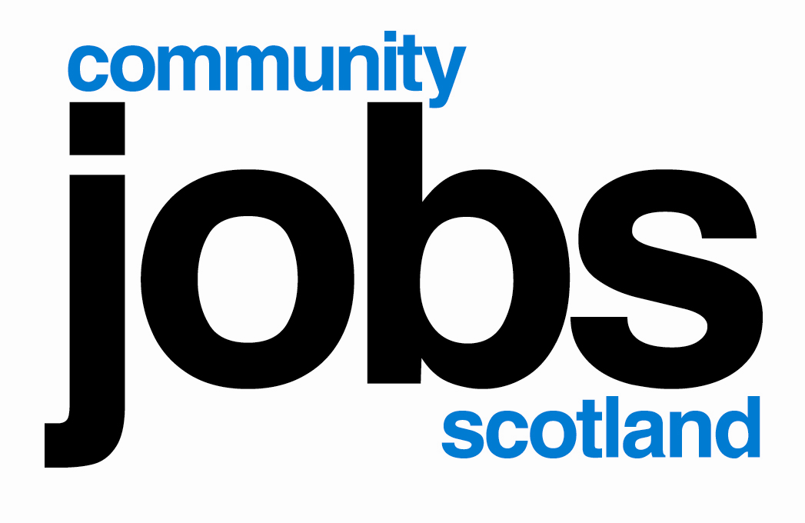
Eligibility Referral Form

Community Jobs Scotland (CJS) is a Scottish Government funded programme, the Scottish Council for Voluntary Organisations (SCVO) manages the CJS programme.

Applicants are unemployed young people aged 16 -29 years with a disability or long term health issue and not participating on the Specialist Employment Support, Work Choice, Fair Start Scotland, Work First Scotland or Work Able Scotland.

Applications cannot be submitted for any young person who has previously participated on Community Jobs Scotland.
To be completed by JCP/SDS advisor with original, signed copy forwarded to employer
Job Title |  |  |  |  |  |  |  |  |  |  |  |  |  | Referral office address /stamp
Job No.
Employer
Contact
Address
 |  |  |  |  |  |  |  |  |  |  |  |  |  | Advisor Email
Tel. No |  |  |  |  |  |  |  |  |  |  |  |  |  | Tel. No
Applicant Details
Title |  | Mr |  |  |  | Mrs |  |  |  | Miss |  |  |  |  | Ms |  |  |  |  | Other
First Name |  |  |  |  |  |  |  |  |  |  | Surname
D.O.B |  |  |  |  |  |  |  |  |  |  | NI No.
Tel./Mob No. |  |  |  |  |  |  |  |  |  |  | Email
Applicant is: |  |  | 16 to 29 years old |  |  |  |  |  |  |  |  | Has a Disability/Health issue
Disability Health Issue
Referral Arrangements (tick as appropriate)
Application/CV attached to be forwarded to employer |  |  |  |  |  |  |  |  |  |  |  |  |  |  |  |  |  |  | OR
Interview arranged |  |  |  |  |  |  | on at am/pm

Declarations-completed by Jobcentre Plus/Skills Development Scotland advisor and applicant
I can confirm that the above named is eligible to participate on the Community Jobs Scotland programme and is not a participant on the SES, Work Choice, Fair Start Scotland, Work First Scotland or Work Able Scotland. I confirm that the young person has a disability or long term health issue.
Advisor Signature |  | Print  Name |  | Date

I agree to Jobcentre Plus/Department of Work and Pensions/Skills Development Scotland forwarding my details to the above named employer and for that employer to provide feedback on my application and interview. This form will also be forwarded to SCVO by the employer to confirm eligibility for the Community Jobs Scotland programme.
I confirm my application for this vacancy and have not previously participated on Community Jobs Scotland. I confirm that I have a disability and or long term health issue.
Applicant  Signature |  | Print  Name |  | Date

Each Employer must complete the following sections

To assist each young person in the development of their jobsearch skills we need to know why they were successful/unsuccessful at interview (highlight areas requiring additional work or where they performed well).

Complete the following Application/Interview Outcome and Interview Assessment for all applicants

Application/Interview Outcome - To be completed for all applicants
Application/CV not received |  |  |  | Did not attend interview
Appl received, not shortlisted for interview |  |  |  | Attended interview but not offered post
Successful at interview |  |  | Start date and time

Interview Assessment Form
Application Form: comment on spelling, grammar, quality and quantity of information provided e.g. qualifications gained, skills, interests etc.
Preparation: comment on applicant’s knowledge of your organisation, understanding of the job role, their presentation, time keeping etc.
Communication: comment on speech – was it clear?, ability to respond to questions, ability to talk confidently about their skills, experience etc.

Return a copy of the completed form to the JCP/SDS advisor within 2 days of completion of interviews, for all applicants (this can be done by email)

For all applicants, forward a scanned copy of this completed document to your SCVO Account Manager or post to; CJS Team, SCVO, Brunswick House, 51 Wilson Street, Glasgow, G1 1UZ.

Please note the form MUST be signed by a JCP/SDS advisor.

You can read our full privacy statement on the SCVO website at: www.scvo.org.uk/privacy

